Custom Flows

Suggestive TIP Prompt
DC Direct supports suggestive tip prompting on select supported PIN pads.
When the Gratuity value is “SuggestivePrompt”, this field defines the values displayed in the custom gratuity buttons. Four values must be provided, using format “Button1-Label [colon] Gratuity1-Amount [comma] Button2-Label [colon] Gratuity2-Amount [comma] Button3-Label [colon] Gratuity3-Amount [comma] Button4-Label [colon] Gratuity4-Amount” (ex: 10%:1.00,15%:1.50,18%:1.80,20%:2.00).
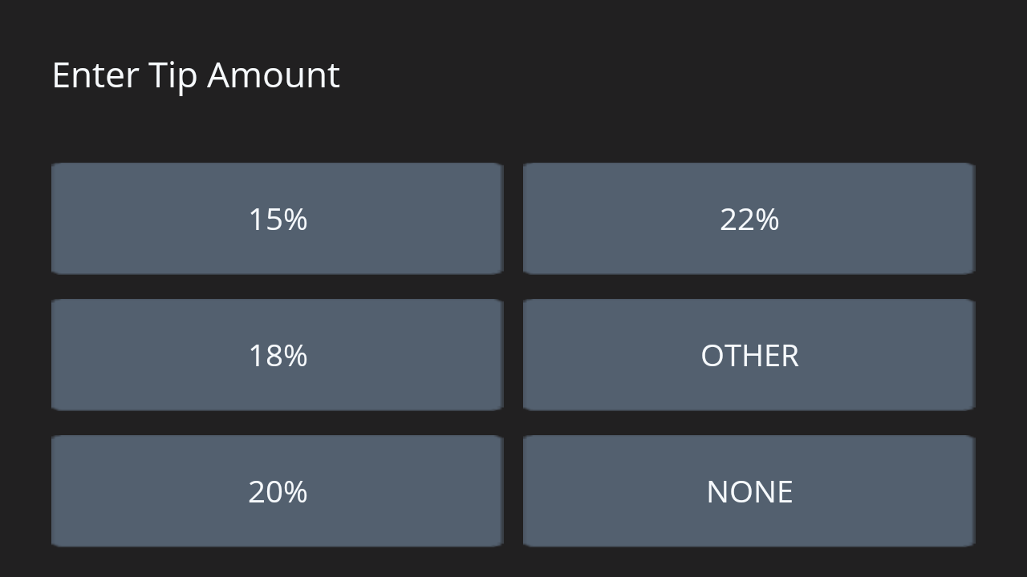 | 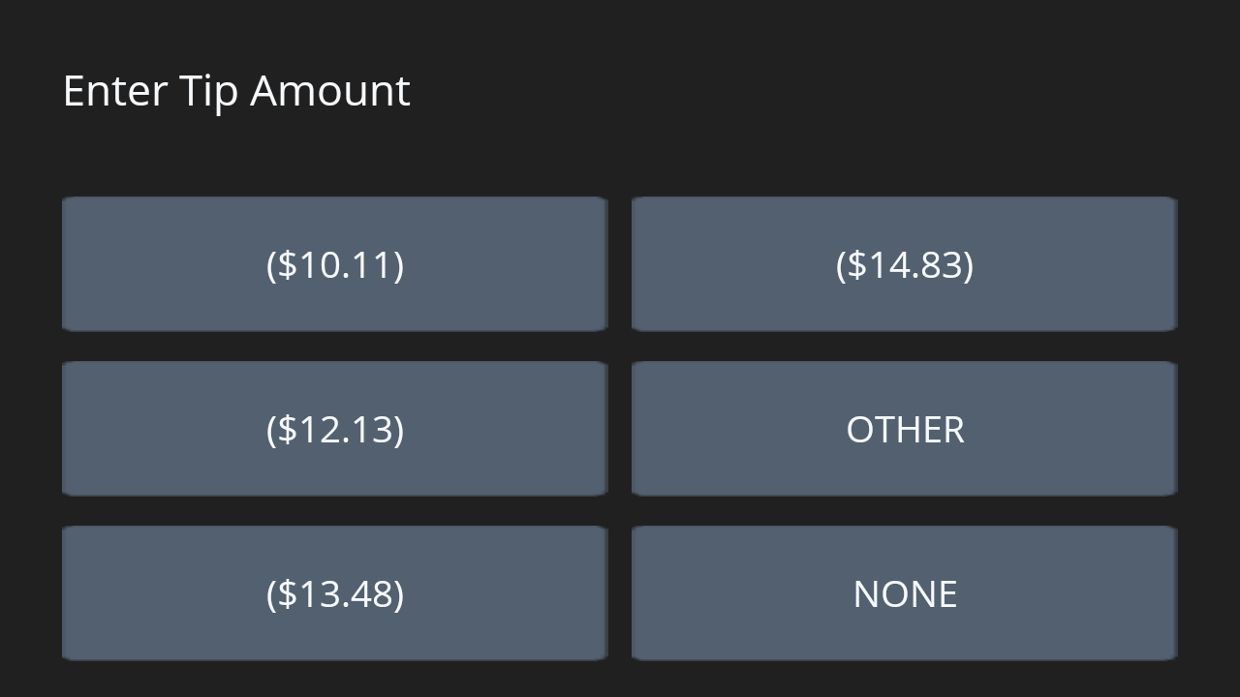
Tip Prompt using percentages | Tip Prompt using amounts
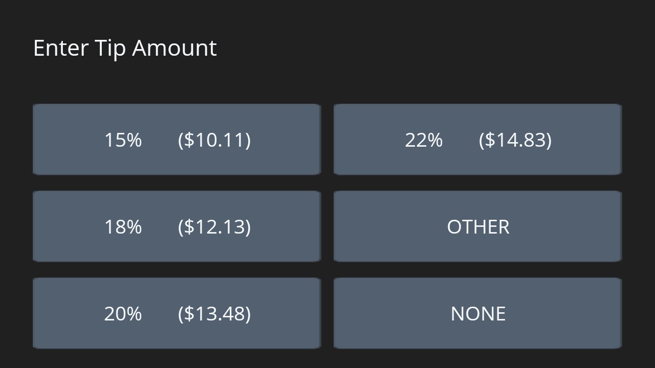 | 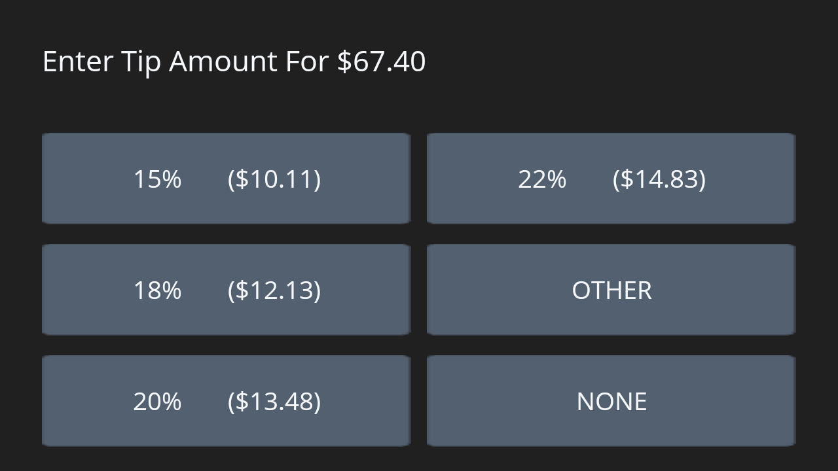
Tip Prompt using percentages and amounts | Tip Prompt including the amount total
If one of the buttons are pressed, the corresponding gratuity amount is used for the transaction. The gratuity entry form also has a button for “Other” and “No” or “None”. Pressing “Other” will cause the pad to display a prompt to manually enter a gratuity amount. Pressing “No” or “None” will cause the pad to skip any gratuity entry.
View Demo

Pay At Table
Pay at Table: Step by Step
Our implementation of Pay at Table works as follows:
- Your POS initiates the Pay at Table sequence.
- GetYesNo - Prompts the server to confirm Pay at Table “mode”. Returns No or Yes as an answer.
- GetYesNo - Asks if the customers would like to split the bill. Returning No or Yes as an answer.
- GetMultipleChoice - Called to provide options for how many ways the check can be split. Returns the number of splits. (This will determine how many loops the tip selection will run for.)
- GetYesNo - Asks if the customers would like to split the bill evenly. (Informs the POS how to split the total across the individual payments) Returns No or Yes as an answer.
- GetYesNo - Shows the customer their share of the bill and asks if they want to add a gratuity. Returns No or Yes as an answer.
- GetSuggestiveTip - Prompts the customer to select a tip percentage (you may optionally calculate the dollar amount and present it next to the percentage on the button). Returns the value of the selected button.
- GetYesNo - Asks the customer if they would like a receipt for their payment
- EMVSale - Uses the information gathered in previous steps to charge the customer’s card.
- PrintReceipt - Uses the print data returned from the sale to print the receipt for the sale.
- Repeat steps 6-10 per each customer specified in step 4.
- DisplayOnDevice (Optional) - Displays custom text to the device, in this case informs the user that Pay at Table is exiting.
View Demo

Custom Amount Format
On Android devices, DC Direct supports the <CustomAmountFormat> field, which allows integrators to display a custom message to the cardholder on the “collect card data” form screen.
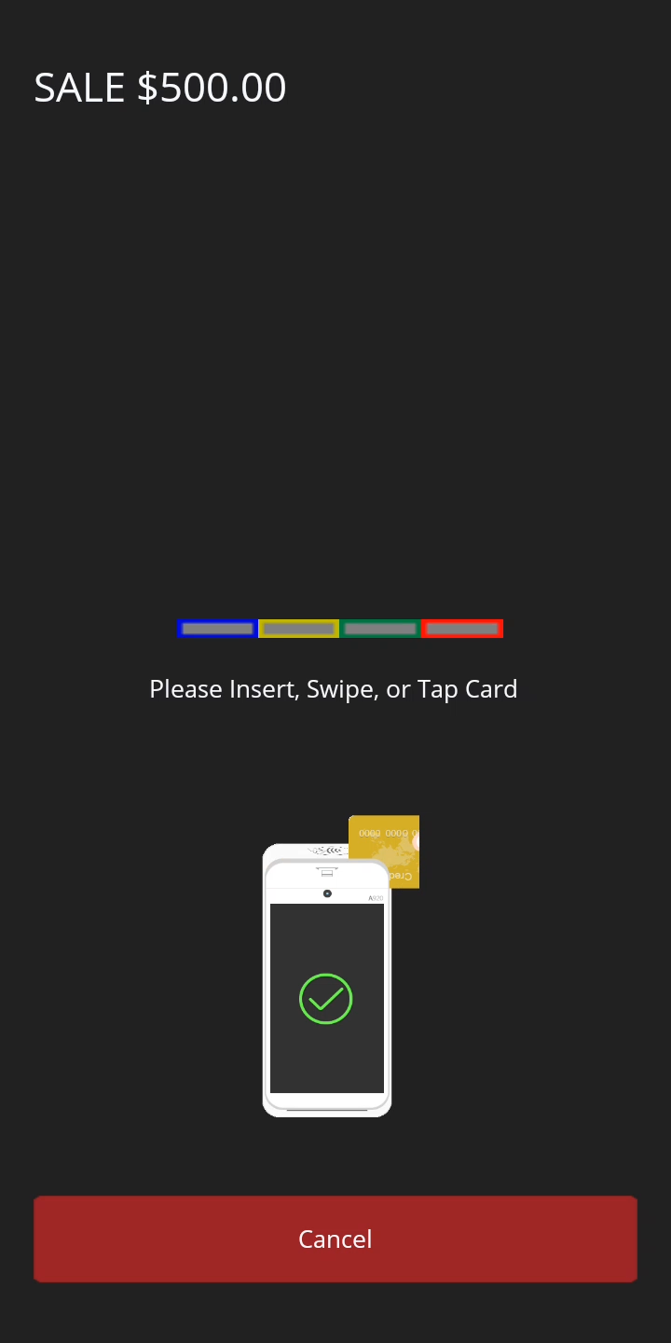 | 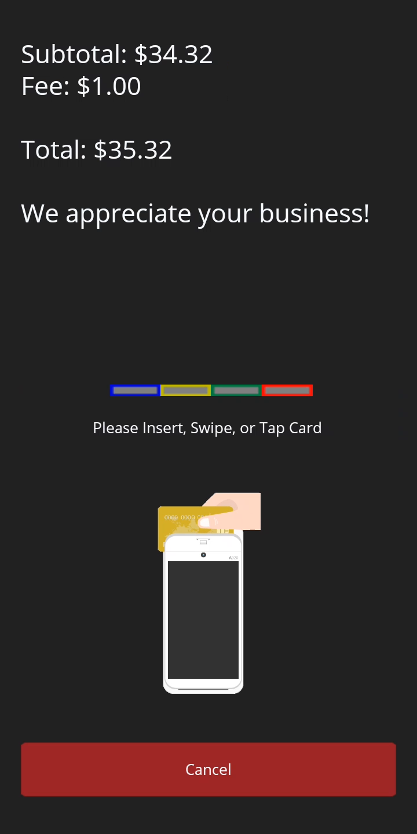
Standard Card Collection Screen | Custom Amount Format
For Android devices, the <CustomAmountFormat> tag includes the following predefined elements:
- #PAYMENT# - The amount of the payment (Purchase + Gratuity + Cash Back).
- #GRATUITY# - The amount of the tip.
- #N# - a new line.
- #FEE1# - The amount of SplitFee1.
- #CASHBACK# - The cashback amount.
- #PAYMENTFEE# - The amount of the “Payment Fee”.
- #TAX# - The amount of the tax.
- #SURCHARGEWITHLOOKUP# - The amount of the surcharge.
- #PAYMENT_WITH_SURCHARGE# - The total amount of the payment with the surcharge (Purchase + Gratuity + Cash Back).
Note: #PAYMENT# and #PAYMENT_WITH_SURCHARGE# will still include Gratuity and Cash Back even if displayed separately.
Example of the CustomAmountFormat sent on an EMVSale:
<CustomAmountFormat>Payment Amount: $#PAYMENT##N#Fee Amount: $#FEE1#</CustomAmountFormat>
For additional examples, see EMVSaleWithSplit. <CustomAmountFormat> is not exclusive to EMVSaleWithSplit and can be used with other transactions.

Custom Forms
Integrators can develop/design their own forms packages on Android devices. To use a custom forms package, the <UseForms> tag must be sent as part of each transaction request.
EMVSale with custom forms
- xml
- json
POST /ProcessEMVTransaction/ HTTP/1.1
Host: 192.168.1.232:8080
Content-Type: application/xml
Content-Length: 503

<?xml version="1.0"?>
<TStream>
<Transaction>
<MerchantID>DEMODCHALGP</MerchantID>
<UserTrace>CustomForms</UserTrace>
<POSPackageID>PyTest:2.0</POSPackageID>
<TranCode>EMVSale</TranCode>
<SecureDevice>EMV_A920PRO_DATACAP_E2E</SecureDevice>
<RefNo>6773577033</RefNo>
<InvoiceNo>6773577033</InvoiceNo>
<SequenceNo>0010016100</SequenceNo>
<OperatorID>001</OperatorID>
<TranDeviceID>1640014855</TranDeviceID>
<UseForms>TotallyDifferentForms</UseForms>
<ReturnClearExpDate>Allow</ReturnClearExpDate>
<ReturnClearCardBin>Allow</ReturnClearCardBin>
<Duplicate>None</Duplicate>
<Account>
<AcctNo>SecureDevice</AcctNo>
</Account>
<Amount>
<Purchase>6.19</Purchase>
<Gratuity>10.00</Gratuity>
</Amount>
<RecordNo>RecordNumberRequested</RecordNo>
<Frequency>OneTime</Frequency>
<PartialAuth>Allow</PartialAuth>
</Transaction>
</TStream>

Alternate forms
Datacap has already implemented custom forms which are ready for use out of the box.
Send <UseForms>Datacap2Light</UseForms> with your requests to make use of “Light Mode” payment forms. (Currently only available on PAX Android Devices)
Note To use Datacap’s light mode forms, please download the latest forms package release from Datacap.
Examples
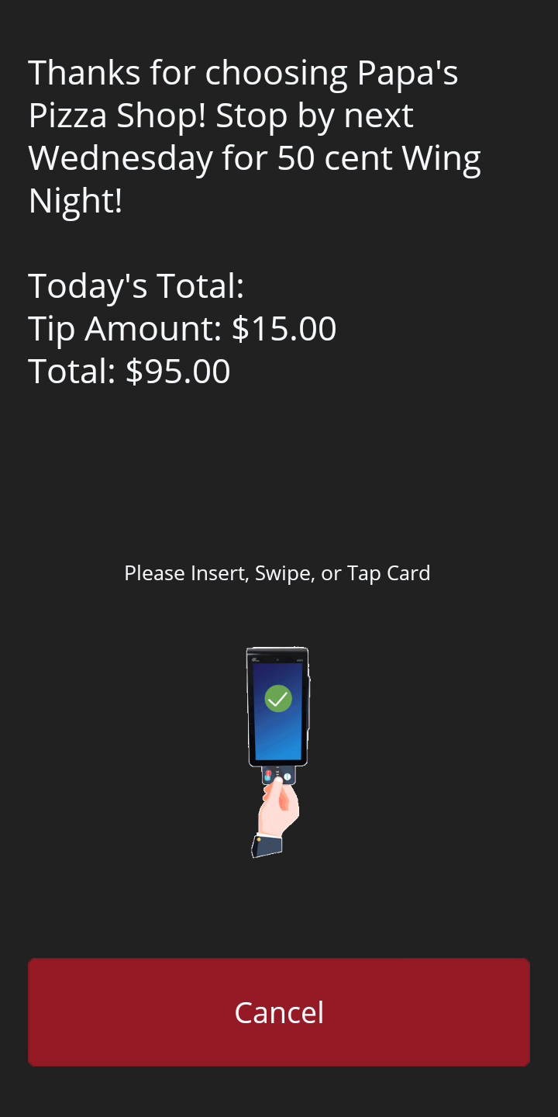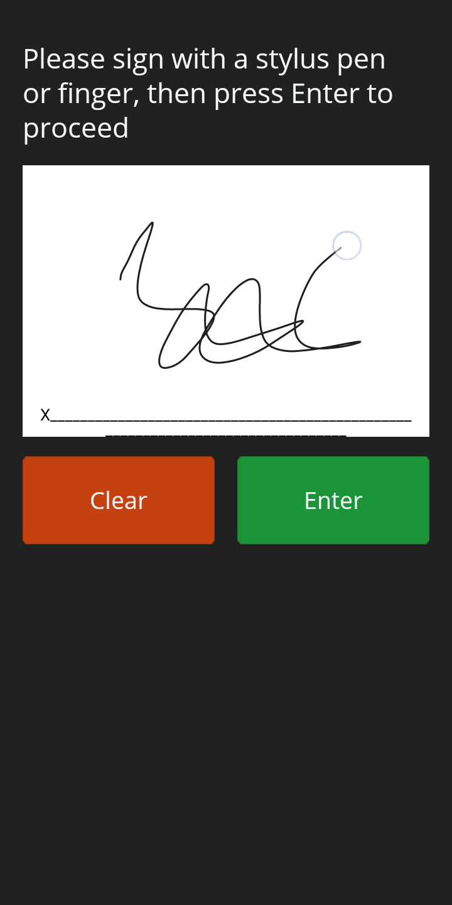 | 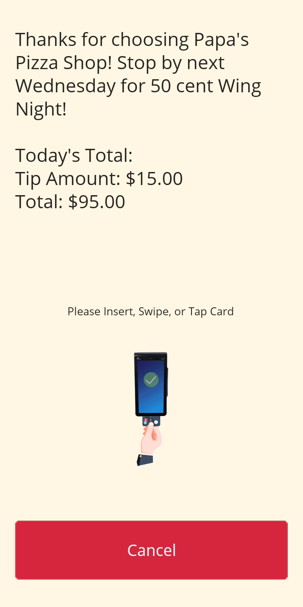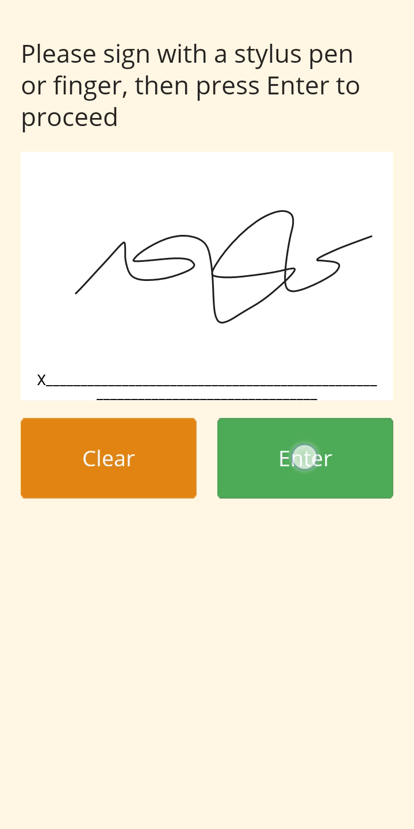
Default Form | Light Mode

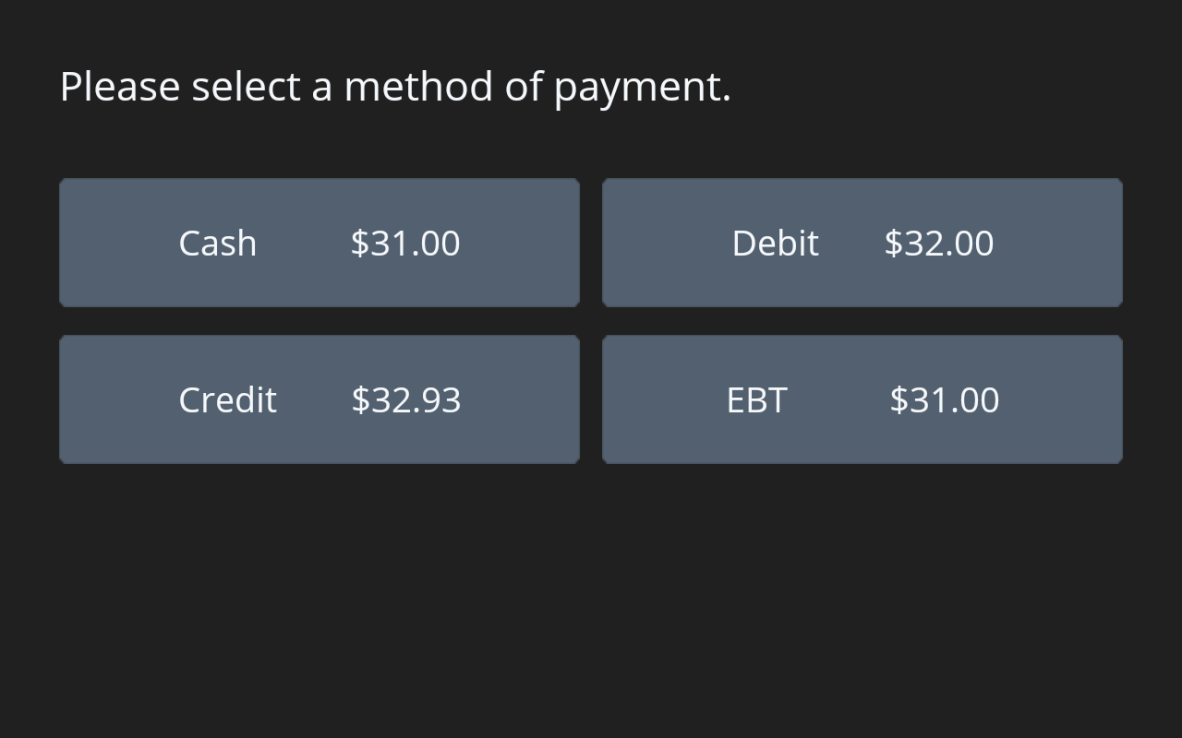 | 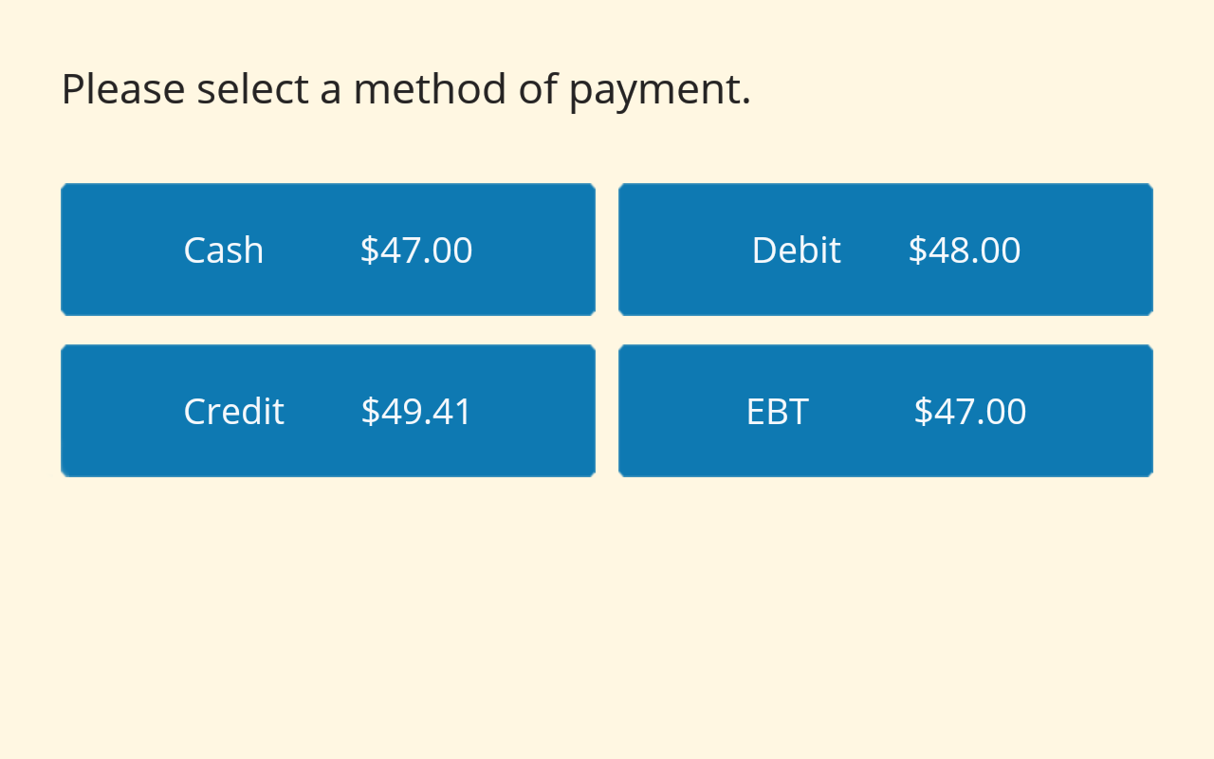
Default Form | Light Mode

Pre-Dip/Tap
Support for Pre-Dip/Tap was added to DC Direct 2.0.3
Pre-Dip/Tap allows for customers to dip or tap their card prior to the sale
To use Pre-Dip/Tap, integrators must use the CollectCardData.
CollectCardData Sample Request
- xml
POST /ProcessEMVTransaction/ HTTP/1.1
Host: 192.168.1.232:8080
Content-Type: application/xml
Content-Length: 98

<?xml version="1.0"?>
<TStream>
<Admin>
<PlaceHolderAmount>1.00</PlaceHolderAmount>
<TranCode>CollectCardData</TranCode>
<SecureDevice>CloudEMV2</SecureDevice>
<TranDeviceID>1710035488</TranDeviceID>
</Admin>
</TStream>


